7th Edition (2020) Code – Proposed Code modifications

Quick Reference Guide
Definitions |  |  | Mod – proposed code modification  The Code – The Florida Building Code  Staff – DBPR , Codes and Standards Staff
Search For a Mod |  |  | To search for a Proposed Code Modification navigate your browser to www.floridabuilding.org. You should see a page with a large blue menu on the left.  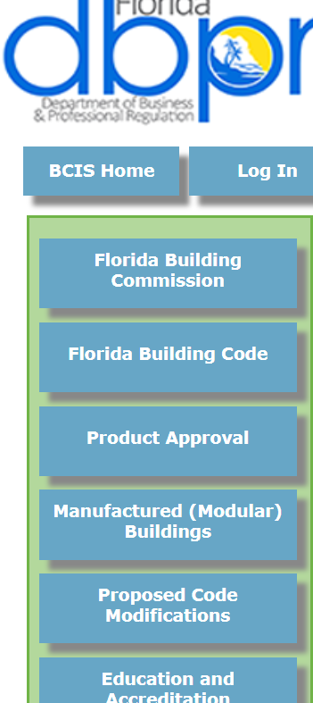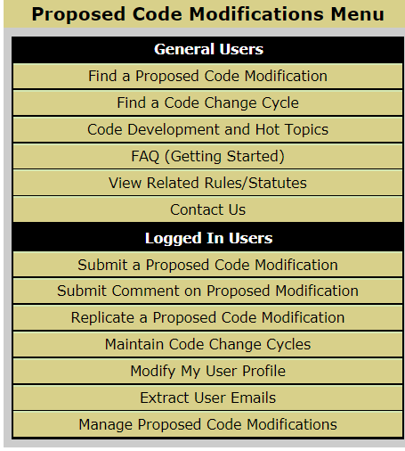  Do the following steps:  - Click “Proposed Code Modifications”. This should pull up a new menu screen. To find a Mod, select Find a Proposed Code Modification.  Note: There is no need to register or log in to search.  Here a search screen should load. You can enter in the 4 digit mod number and click search, or you can enter in some of the variables to search for a specific Mod.  Note: Mod prefixes like CA#### are not needed, enter the 4 digit mod number to avoid getting this error.
Note: Looking for a Mod that you have previously submitted, but it doesn’t come up? it may be in a temporary “holding bin” for DBPR staff to review. In that temporary status the mod is un-viewable by the general search. Check your “Manage Proposed Code Modifications inbox for its status. For more information see “Manage Proposed Code Modifications” below.
Note: If you don’t receive any results try broadening your search by removing some of the search variables by making them (Select All).
Registration |  |  | Registration on the BCIS is crucial for submitting and participating in the 7th Edition (2020) Code development cycle. In addition to Mod submittal and code development, notices and meeting information is periodically sent to those registered with the BCIS at www.floridabuilding.org.
 |  | New Users | - If you intend to submit proposed code modifications it is recommended to register if you haven’t already. The process is easy and the next few steps will guide you through the process.  - You can register by clicking at the top of the BCIS page “User Registration” Here you will enter all of your contact information, including an email address that you check often.
 |  | Returning Users | - Returning users only need to click on login and enter their login and password. There is a “forgot password” feature if you have forgotten your password. Contact us if you have forgotten your user login. We can be reached at 850-487-1824.
Submit a Mod |  |  | This section describes the steps to create a new Proposed Code Modification.  To submit a Proposed Code Modification, navigate your browser (IE only) to www.floridabuilding.org. You should see a page with 6 large multicolored buttons.  - To submit a Mod you will need to be logged in as a BCIS user. (See User Registration section for information on how to register) See Item 4 below.  Note: Before starting the proposed Code Modification application online it is recommended that you have your mod “preassembled” in a word processing program.  Note: Proposed Code Modifications submitted after the deadline will go into an “on hold” status until a new cycle opens.
 | Page 1 – Code Criteria |  |  | The system automatically selects the latest Code Version.  * Required fields  - All required fields are marked in blue with asterisks.  For the Related Modifications box, provide Sub Code and section(s) for other code modifications that you are proposing that are related to this mod. Add mod number if known.  - For further information see the “Needs Help” link for a .pdf describing the section.  Note: Save in Progress saves your information if you feel you may timeout your session. It is a good rule of thumb to click this if you are going to be working on a page for a while. Clicking “Next” will also save the page in progress and advance to the next page of the mod.
 | Page 2 – Text and Rationale |  |  | This page is where the text for the mod is entered. Here there is a link that will take you to the required documents to be used as guidelines for your mod.  - Click on Required documents to be used as the basis for proposed code modification for 7th Edition (2020) FBC.  In the middle of the page is the ‘Text of Modification’ box.  It does contain many word processor functions, but it is recommended to formulate your mod in a word processor on your machine.  Also be sure to save your mod in your word processor to ensure you have a backup in case the BCIS produces an error. For further help click on the “Needs Help” file.  Note: The pages of the application are on a timer. You may lose your material if you don’t save in progress often or work locally on a word processor. There is a timeout function that will time the mod out if no saving or action is being done for 15 minutes (typing in the box will not update the timeout).  Note: The web site has been enhanced for the 7th Edition (2020) to allow the use of different browsers. However, Internet Explorer is still recommended if available for your system. Other browsers may be incompatible. Please contact us at 850-487-1824 if you have any questions.
 | Page 3 – Impact Statement |  |  | For the Impact Statement boxes, answer all questions regarding the impact of your code change proposal.  For further information, see the “Needs Help” link for a .pdf describing the section.  Note: You can also upload a Support File for this section.
 | Page 4 - Requirements |  |  | Answer all questions regarding the specific requirements of submitted mods.  For further information see the “Needs Help” link for a .pdf describing the section.  Note: You can also upload a Support File for this section.
 | Page 5 - Summary |  |  | This is the final page just before submitting the mod. Ensure that everything is correct. If you see a section that needs work, just click on the ‘Edit’ link next to the section to return to the section. You may have to navigate through a few pages to get back to the summary.  Note: Once you feel it is complete, it is recommended that you print this page.
Submit a Comment |  |  |  | You may wish to submit a comment on a proposed code mod. If the comment period is open you can submit a comment - either a general comment, or an alternate language to the proposed code modification. First log in to floridabuilding.org and then Search for a mod that you would like to comment on by going to “Find a Proposed Code Modification”. Click on the link of the mod number to go in to the mod summary. At the bottom of the mod summary there is an option to “Submit a Comment”. Click the button and you will be asked whether you want to submit a general comment or an alternate language comment. There is a guide below on which to use below. General comments are limited to only a few paragraphs. Alternate language comments can be larger.  Note: You may receive periodic emails to inform you of the status of your mods, so it is a good practice to look for these emails from DBPR staff and the automated website emails.
 | General Comment |  |  | General comments are for any comment that doesn’t include alternate language. This section is limited to one Text box for users to either cut and paste into or type live.  There is also a “Needs Help” file here with information in case you get stuck.  Note: General comments are limited to only a few paragraphs and one file upload.  Note: General Comments are shown as modnumber-G1, -G2, etc. The “G” is generated by the system to indicate it is an “General” comment.
 | Alternate Language Comment |  |  | If you find a mod that you feel would be improved if it had different language, you can submit an alternate language mod. Once you click on “submit a Comment on a Code Modification” select the Alternate language radio button. Here you will have almost all of the options of a whole mod including the text of mod fields.  Here add the text of the Modification as the text of the Comment.  Note: Alternate language Comments are not limited to text and uploads.  Note: Alternate language Comments are shown as modnumber-A1, -A2, etc. The “A” is generated by the system to indicate it is an “Alternate Language” comment.
Manage Mods |  |  |  | Once you have submitted a Mod you will want to track its progress throughout the Code Change Cycle. The following steps will help you monitor your mod:  Note: You may receive periodic emails to inform you of the status of your mods, so it is a good practice to look for these emails from DBPR staff and the automated website emails.  Note: If you submit a mod outside of a cycle your mod may go into an “On-Hold” status. This is a temporary holding bin where there is little access to your mod once it is submitted. You can keep track of this on-hold mod by following the notices in your inbox.
 |  | Notices |  | Depending upon the mods you have submitted you will see various types of notices. The notices tab is split into two different sections. The top section visible is the “Action Required”. This will give you information on mods that need the most immediate attention.  In the bottom pane is the “Information Only” area. These are just informational and do not require your immediate involvement. These are good to follow just to keep track of where your mod is in the cycle and how many days it has been there.  Note: You can remove notices by checking them and clicking the remove button.
 |  | Saved In Progress |  | These are your mods that you have saved in progress and have not completed.  - To access a Saved in Progress Mod: Click the saved in progress tab and then click on a mod proposal number. Here you can continue through the mod to do a final “Submit”.
 |  | Need More Information |  | This is a holding status that DBPR staff can issue to a mod. These notifications come up under “Action required” notices. Until the changes are submitted the application will remain in this status.  Note: It is recommended to check periodically the status of your mod. It may have been put in a temporary status.
 |  | Pending DBPR Review |  | If the mod is submitted during a cycle it is automatically set to this status.
Help? |  |  |  | There are further resources available to use to learn about how to use the Proposed Code Modification Module and the Code development process.
 |  | “Inline” Help |  | For further information see the “Needs Help” link for a .pdf describing the section.
 |  | Code Development |  | For information on code development go to www.floridabuilding.org, click on Hot Topics and then click on Code development.
 |  | Proposed Code Modifications |  | For information on proposed code modifications go to www.floridabuilding.org, click on Proposed Code Modifications and then click on FAQ (Getting Started).
 |  | BCIS |  | There is a lot of Code related and Florida Building Commission material on www.floridabuilding.org. A good place to start is by clicking on “Hot Topics” at the top menu bar of the homepage. You can also click on “Publications” to view some of the reports and periodicals that have been produced.
There are many good resources on www.floridabuilding.org. For information specific to Proposed Code Modifications you can easily consult a list of Frequently Asked Questions. To find these, do the following: Here you should have a screen with 6 large multicolored buttons.
- Click or hover over “Proposed Code Modifications”. This should pull up a dropdown menu or take you to a new menu screen. Then click on “FAQ (Getting Started).
  - Here you will find the latest information on Proposed Code Changes, calendars, and Frequently Asked Questions.
Note: If you are unable to find the answer to your question please contact DBPR staff at 850-487-1824 and we will be happy to assist you.

